**Rulesets**

In PEGA only15 rule categories are there

When we create new casetype

Case type rule

Py default

Process rules

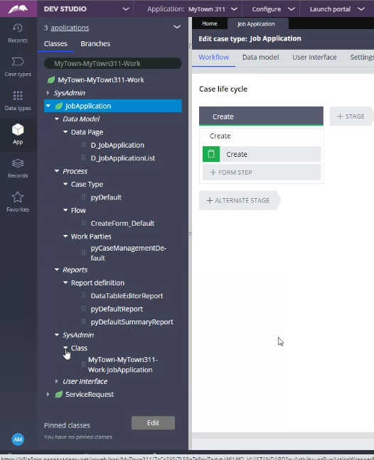

For any casetype

When we created a new application how many rulesets are created by PEGA

2 for organization (VRS)

VRS:01-01

VRSInt:01-01

2 for application(MyApp)

MyApp:01-01

MyAppInt:01-01

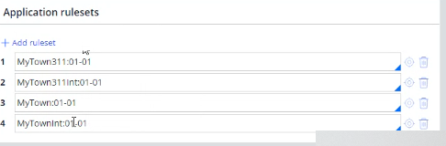

Rule resolution algorithm can automaticaly identify the patch version while searching the rule

Rule Resolution algortithm Used to find right rule for execution alaways picks from the highest version

How to create new rule set version?

***Ruleset stack***

The ruleset stack lists the rulesets and ruleset versions

that make up the application including those inherited

from any built-on applications

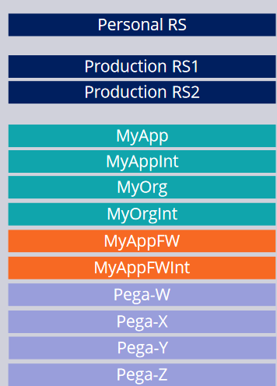

Production rule set used for delegation

***Ruleset versioning:***

Developers collect rules into an instance of a ruleset, called a ruleset

version

***Skimming:***

Skimming is saving the highest version of a rule into a new, higher ruleset version.

Copying the rule set from highest ruleset version